ASN7: Data Fundamentals III Prep - [Noah Tanenholtz]

Use this three-page template to organize your correlation table and Excel figures into one document.
Once complete, submit this to ELMS for your ASN7.

Table 1. Correlation between political variables
 | Rs highest degree-INT | Political party affiliation-INT | Self as liberal or conservative-INT | adequate standard of living-INT | govt protect right of minorities-INT | ppl given chance to participate in decsns-INT | citizen engage in acts of civil disobeyed-INT
Rs highest degree-INT | 1
Political party affiliation-INT | -0.00092 | 1
Self as liberal or conservative-INT | -0.09205 | 0.510094 | 1
adequate standard of living-INT | -0.018992 | -0.14646 | -0.11974 | 1
govt protect right of minorities-INT | -0.088309 | -0.21165 | -0.18744 | 0.429752 | 1
ppl given chance to participate in decsns-INT | -0.03319 | -0.10895 | -0.0746 | 0.269327 | 0.376608 | 1
citizen engage in acts of civil disobeyed-INT | -0.091143 | -0.08736 | -0.16593 | 0.059068 | 0.118792 | 0.117617 | 1

Figure 1. Scatterplot of Technological Variables

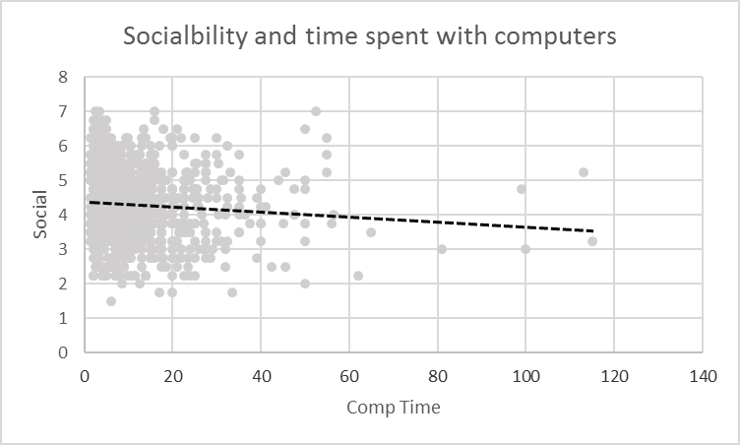
Figure 2. Histogram of Political Variable

